Define and describe your problem. What kind of problem do you want to solve? Keep it simple and solvable; rather than “solve world hunger,” you might try “sandwich making robot.” It should involve an Internet-connected device.

Do a literature search in the HCI conferences (CHI, UIST, Ubicomp, ISWC, and so on) and summarize how other people have approached this or similar problems. Also look at various IoT objects at [iotlist.co](http://iotlist.co/) and other places.

Describe your proposed solution.

Outline the steps you will take to implement your solution.

Problem Definition

With the development of modern computer technology, people nowadays have unprecedented number of choices to gather the information created by the actions inside or around their houses, such as video recording, motion detecting, temperature or sound monitoring. While many smart home monitoring systems are able to record and store the data under time sequence, most of them keep the data separately. This makes people in the house less likely to review the data, since it consumes much time and effort. Smart video cameras can store the surveillance video continuously, but people might not willing to watch the content, and research also indicates that people might feel uncomfortable to have all their movement at home recorded. If users purely want to know whether their family members or pets were at home at a certain time, motion sensors might more favorable than cameras.

Other types of information, such as the sound, light, temperature or power consumption of a house, are rarely tracked based on the time. Although they are less expressive than the video footage, combining and comparing different types of data might be enlightening and interesting to common people, as that can be seen as the life log of the house. However, it is hard to find an implementation that successfully visualized those data in common houses. It can be intriguing if a device can blend in the household environment and visualize information from multiple source in the house in an artistic way.

Motion detectors can be used not only as a way to detect intruders of the house, it can also used to track the movement status of the residents. As we known that sitting in front of the computer or TV are usually not healthy for people, it is possible that motion detectors can track residents’ motion in the room and notify them when they have sat too long.

Related research

Combining different sensors in surveillance has become an evolving research area [2]. Johns Hopkins provided a method to design such multimedia surveillance system, which addressed the problem related to deployment of multiple sensors [3]. Efforts were also made to address the issue about coordination of multiple video camera. However, less researches explore dimensions of the representation of surveillance data around the house. Eun Kyoung Choe and Sunny Consolvo, demonstrated that people would not want to be recorded at home through an anonymous survey. This indicates the importance of the use of sensors and the approach of data visualization.

On the other hand, periodical data is also presented in various physical forms. The studio NAND has presented EMOTO, which use 3D physical data sculpture to visualize the global response around the London 2012 Olympic Games on Twitter. In other work, Laurie Frick demonstrates her daily activities and nightly sleep data with 2D ink and watercolor drawing. And the Physical Visualization website [http://dataphys.org/list/] also shows a list of physical data visualization examples.

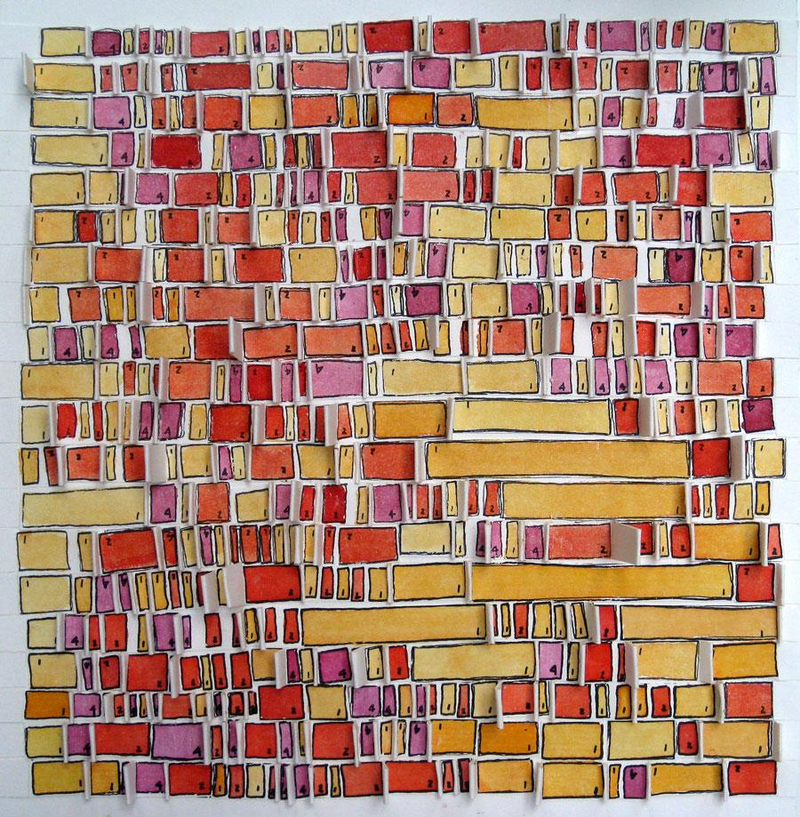

Laurie Frick's *Pokey Red* is a physical visualization of sleep data over a month

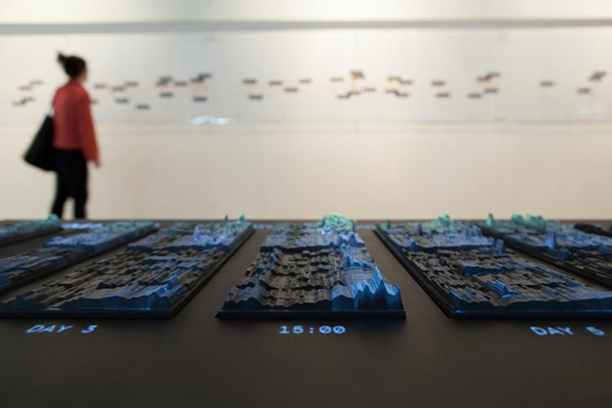

2012 – Emoto: Visualizing the global response at the

London 2012 Olympic Games on Twitter.

On the whole, we realize that discussion related home surveillance system less focused on the expressions of its data, which however have rise a reasonable research interest.

Proposed solution

Our group believes that based on what we have learned in this course, it is possible to build a system which collects one or several types of data from sensors, then records and presents the data with a less intrusive output. We think users can benefit from looking at this output to learn more about what has happened recently. As pet owners can check how was their pet doing along at home; tenants can check how the public space and utilities are used; families can share more detailed information with each other and know deeper about the house. Since the data is transmitted through the internet, when the sensors separate from the output, users might able to see the status of their house or share it with other people.

Implementation

We are thinking about using several internet-enabled micro-controllers with sensors to monitor the house and send the data to a central micro-controller which controls the output system. The output system is in charge of visualizing the data under timely order. As we are inspired by the electrocardiograph device, our current design it to build the output system with several colored pens controlled individually moving on a roll of paper or a plate of paper. Other materials will be considered if possible. If pen heads are moving in a circular motion, it might be also used as a wall clock, which the hour hand is drawn on the paper with colors. But this will require users to change the clock face paper each 12 hours after on circle is completed. Otherwise, if the paper is going from one roll to another, the drawing can be kept longer than a day.

We are still discussing and finding a better way of implementing our concept, more interaction might be added if time permits.

Reference

1. Choe, E. K., Consolvo, S., Jung, J., Harrison, B., & Kientz, J. A. (2011). Living in a Glass House: A Survey of Private Moments in the Home. In *Proceedings of the 13th International Conference on Ubiquitous Computing* (pp. 41–44). New York, NY, USA: ACM. <http://doi.org/10.1145/2030112.2030118>
2. Luo, R. C., Yih, C.-C., & Su, K. L. (2002). Multisensor fusion and integration: approaches, applications, and future research directions. *IEEE Sensors Journal*, *2*(2), 107–119. http://doi.org/10.1109/JSEN.2002.1000251
3. Sivaram, G. S. V. S., Kankanhalli, M. S., & Ramakrishnan, K. R. (2009). Design of Multimedia Surveillance Systems. ACM Trans. Multimedia Comput. Commun. Appl., 5(3), 23:1–23:25. http://doi.org/10.1145/1556134.1556140